**Implementing Mobile Apps – GoodStuff**

For the Implementing Mobile Apps course in spring of 2016 we have decided to create a simple application, which will contain some basics that we have covered during the course thus far. During the course we have looked into Ionic and visual studio.

We came up the idea to make a picture gallery with grading from one to five and a possibility to leave comments, both of these will be available to anyone without the need of log-in credentials. The gallery will focus in women’s cosmetics.

**The wireframe**

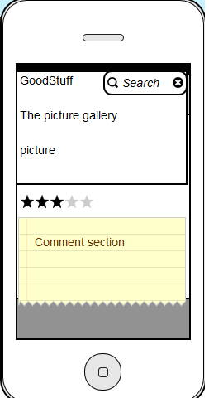

The above picture is the baseline we’re aiming for, but since this a plan things are bound to be different in the end result. All of this has to be broken into many separate bits and pieces. The key point here is how to actually make something even remotely similar to an average picture gallery, which would pop-up into the user’s mind before even seeing the application.

As we can see on the banner of the application will be held the name of the applications, for instance something similar that Instagram has and right next to the title will be the search section. From the search it’s possible for the user to certain brands products. Down below the title & search, will be the key element of the whole application, the picture gallery/a single picture as Instagram has. Lastly the bottom area of the application is reserved for the communication and reviews of the users.

The application deadline will be on 30th of April, together with this project plan.

As a conclusion we will do the very best we can with our resources and skills we have learned and polished up during this short spring semester. We hope to achieve a functional application with a few nice features!

Hanyu Ji 1301742

Joni Haapaniemi 1101083